Labelling Devices for Shelves and Book Spines

I strongly recommend the following device for labelling book spines and shelving. It is really easy to use and you’ll find great use for it elsewhere too.

The hand-held Brother PT-2460 is a portable, easy to handle labelling printer. It produces durable barcode labels, pricing labels and sales messages simply, quickly and efficiently.

The barcode utility is quite important if you want to enable your library users to check items in and out using an electronic barcode scanning system. Whilst most books have unique barcodes anyway, there are other items in your library that won’t have them eg CD-ROMs, video material, important documents or folders etc
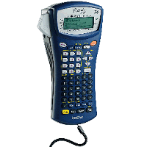

- Portable, battery operated
- Simply ABCD keyboard
- Barcode function
- 16 character x 2 line LCD
- 180 dpi print resolution
- Prints upto 7 lines text on 24mm tape
- Auto numbering and repeat print
- 10 Pre-formatted label templates
Costs around £60

Don’t forget, you need to buy some labels too. The labels this device uses are quite specific, so be sure to buy the correct ones.

http://www.brother-store.co.uk

Visit the above website to either buy this device or its labels.
If you find you cannot buy this particular model (for whatever reason), make sure you get one with a barcode printing utility. The Brother-series of products are very reliable.

